EXERCISE NO:

Design DFA using simulator to accept the input string “a”, ”ac”,and ”bac”.

AIM: To design DFA using simulator to accept the input string “a”,”ac”,and ”bac”.

Input:

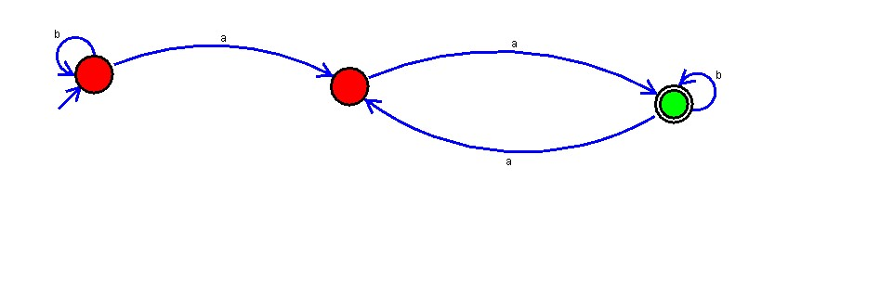output:

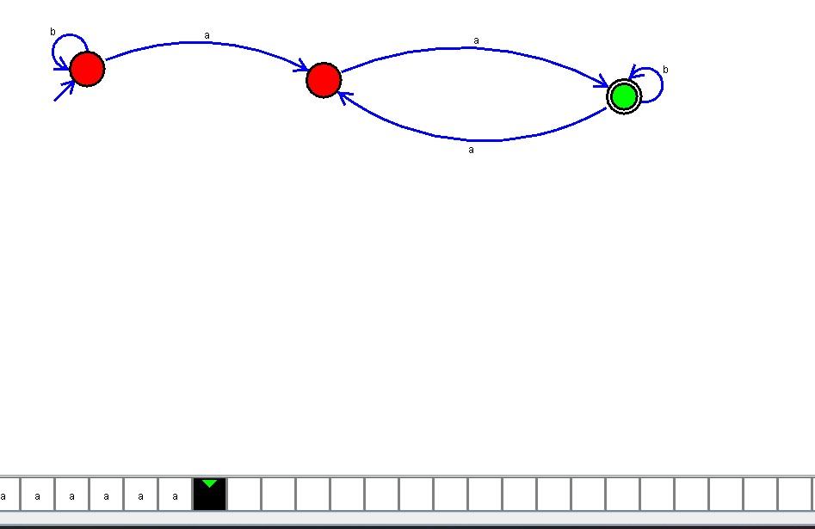

RESULT:

The program executed successfully and got output.